**Worksheet # 5**

**Extra Practice**

**UNIT 5**

1. **Worksheet: Plan Your Perfect Day**

**Fill in: much, many, lots of, a lot of, little, most, a little, little, a few, few.**

1. It seems we have had __________________ assignments in English this year.

2. How __________________ do we have to read this week?

3. __________________ Americans don’t like George Bush

4. There aren’t very __________________ books in the library.

5. I think he drank __________________ wine last night.

6. I have had __________________ headaches already because of the stress.

7. I didn’t use ________________ fertilizer1 last spring, that’s why we had so _________ weeds2.

8. It has rained very __________________ this summer, that’s why the grass is so brown.

9. __________________ people know as much about computers as Jack does.

10. I’m having __________________ trouble passing my driving test.

11. I do have __________________ friends but not that many.

12. How __________________ juice is left in the bottle?

13. John had __________________ money with him so he couldn’t even buy a bus ticket.

14. __________________ time and money is spent on education in Great Britain.

15. I know __________________ Spanish so I am going to have a problem when I get there.

16. __________________ of the children in our block have got roller skates.

17. Football is the only subject I know very _____________ of. It doesn’t interest me that much.

18. __________________ people can live without money. We simply need it.

19. There are __________________ leftovers for you in the refrigerator.

20. Is she already gone? – I’m only __________________ minutes late.

21. There is __________________ doubt that Anne will win the contest.

22. There is not very __________________ dancing going on at the party.

23. __________________ people in the city ride a bike to work because you are simply faster.

24. London has __________________ beautiful buildings.

**RESPUESTAS**

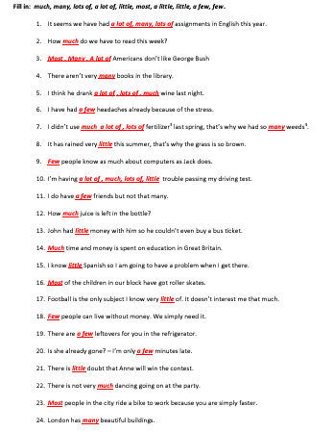

**Online Resources (Quantifiers)**

<https://test-english.com/grammar-points/a2/much-many-little-few-some-any/>

<https://test-english.com/grammar-points/a1/much-many-lot-little-few/>

<https://www.english-4u.de/en/grammar-quizzes/much-many-little-few.htm>